**JC1 H2 Physics**



**Teachers’ Copy**

Name: ………………………………………… CG : …………… Date: \_\_ May 2013

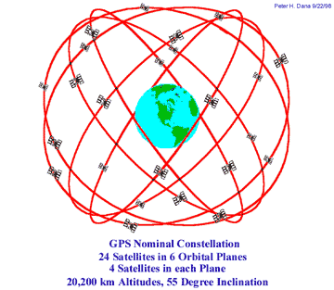

Topic 7 (H2 Physics)

Gravitational Field

*Main Reference:*

* *College Physics – Vuille & Serway (8th Ed)*
* *Physics – Robert Hutching (2nd Ed)*
* *(New) Understanding Physics – Jim Breithaupt (4th Ed)*

***Content***

* *Gravitational field*

The Global Positioning System was developed by the U.S. Military in 1973 and became fully functional in 1995 with 24 satellites in continuous operation. Each satellite circles the earth two times a day and there are four satellites in view from any point on the earth at any given time. The GPS satellite constellation consists of six orbital planes encircling the Earth.

* *Force between point masses*
* *Field of a point mass*
* *Field near to the surface of the Earth*
* *Gravitational potential*

**Learning Outcomes**

Candidates should be able to:

(a) show an understanding of the concept of a gravitational field as an example of field of force and define gravitational field strength as force per unit mass.

(b) recall and use Newton's law of gravitation in the form 

(c) derive from Newton's law of gravitation and the definition of gravitational field strength, the equation  for the gravitational field strength of a point mass.

(d) recall and apply the equation  for the gravitational field strength of a point mass to new situations or to solve related problems.

(e) show an appreciation that on the surface of the Earth *g* is approximately constant and equal to the acceleration of free fall.

(f) define potential at a point as the work done in bringing unit mass from infinity to the point.

(g) solve problems using the equation  for the potential in the field of a point mass.

(h) recognise the analogy between certain qualitative and quantitative aspects of gravitational and electric fields.

(i) analyse circular orbits in inverse square law fields by relating the gravitational force to the centripetal acceleration it causes.

(j) show an understanding of geostationary orbits and their application.

Useful Java simulation <http://weelookang.blogspot.sg/p/physics-applets-virtual-lab.html>

|  |
| --- |
| **7.1 Introduction** |

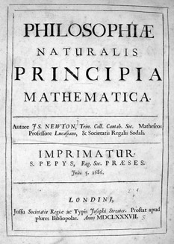 Internet resources :

<http://mathsforeurope.digibel.be/newton2.htm> (Isaac Newton’s biography)

<http://www.physicsclassroom.com/class/circles/u6l3b.cfm> (Inverse square law)

<http://www-istp.gsfc.nasa.gov/stargaze/Sgravity.htm> (Newton’s Gravitational Law)

That Sir Isaac Newton (1642-1727) was the first to discover gravity is a myth. Copernicus, Galilei and Kepler, all astronomers before Newton’s time knew that a force must exist between celestial bodies. Otherwise, for example, the Moon would move off at a tangent if not for the attractive force between the Earth and the Moon. At that time they did not realize that the very force that makes the Moon orbit round the Earth was also responsible for an apple falling towards the Earth’s surface. It was thought that they were two separate phenomena.

1665-1666 was the most productive and creative period for Newton. That was when the Cambridge University had to be closed due to the outbreak of the Great Plague (something like SARS), and he was forced to return to his home which has an orchard. There, he watched an apple falling and speculated that the force pulling the apple towards the Earth must be of the same ‘kind’ that pulls the Moon towards the Earth.

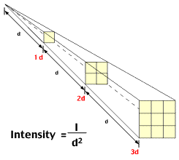

Fig. 7.1 Inverse-square rule

He later successfully verified the experimental data of Kepler and Galilei using the idea of the ‘*inverse-square rule’*. That the Earth’s force of gravity varied inversely with the square of the distance from the centre of the Earth. For example, if an object is moved twice the radius of the Earth from the centre of the Earth, the force on it will be a quarter of the force when it was on the Earth’s surface.

As a result, Newton’s *universal gravitational law* was conceived. So what Newton was really responsible for is the discovery of the *universal gravitational law* and not gravity per se. The term ‘universal’ in this case suggests that the phenomenon applies to all objects, big or small, near or far - that every body of mass has an attractive force for another.

Newton later published his work in ‘*Philosophiae Naturalis Principia Mathematica*’ (Mathematical Principles of Natural Knowledge) in 1687. Following this, Robert Hooke (of Hooke’s law fame) accused Newton of plagiarism claiming that he had stolen from him the notion of the "inverse square rule” and of being too arrogant and conceited. To this, Newton wrote back in a letter. “*If I have seen further than others, it is by standing on the shoulders of giants*." What or who were the ‘giants’ that he was referring to?

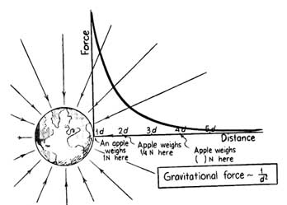

**Inverse-Square Law**

Show that the gravitational acceleration of an object (the apple and the Moon) is *inversely proportional to the square* of its distance from the centre of the Earth.

|  |  |  |
| --- | --- | --- |
|  | Distance from centre of Earth / m | Acceleration / m s-2 |
| Moon | 3.84 × 108 | 2.72 × 10-3 |
| Apple | 6.39 × 106 | 9.81 |

0.000277

0.000277

**7.2 Concept of gravitational field (a type of force field)**

*(a) show an understanding of the concept of a gravitational field as an example of field of force and define gravitational field strength as force per unit mass.*

*(e) show an appreciation that on the surface of the Earth g is approximately constant and equal to the acceleration of free fall.*

In general, a field of force is a region where a body experiences a force due to the presence of another body. Newton’s 3rd law suggests that forces come in pairs; they exert a mutual force that are equal and opposite to each other.

The gravitational field is an example of a field of force. A body, by virtue of its mass, has the capacity to set up a gravitational field around itself. Any other body of mass which lies within this field will be attracted towards the body that creates the field. (Can mass attract mass? Yes, but the effect is very small.)

|  |
| --- |
| **Gravitational field** is a region of space surrounding a body in which another body placed in it experiences a gravitational force due to its mass. |

Gravitational field is invisible and so is represented by imaginary field lines. Where the field lines are very close to each other, the field strength is strong there. Where the lines are separated far apart, the field strength is weak. When the field lines are parallel and equidistant apart, the gravitational field strength is uniform. The lines do not intersect each other.

|  |  |
| --- | --- |
| http://www.aplusphysics.com/courses/regents/circmotion/images/gravfield.gif | http://www.splung.com/kinematics/images/gravitation/field3.gif |
| For a spherical mass, e.g. the Earth, the gravitational field lines are represented by radial lines pointing towards the centre of the sphere. The arrows point to the direction of the force that a test mass placed there will experience. | The effect is equivalent to that of the gravitational field lines pointing towards an isolated **point mass** placed at the centre with all the mass of the sphere concentrated at that point. Field strength obeys *inverse-square law*. |

To simplify our calculations, we will hereon assume the fields and forces due to **point masses**.

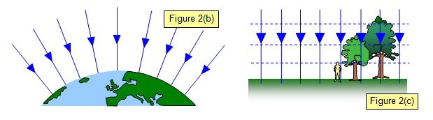

The gravitational field is converging towards the Earth’s centre but at the Earth’s surface, the gravitational field strength *g*Earth is practically uniform.

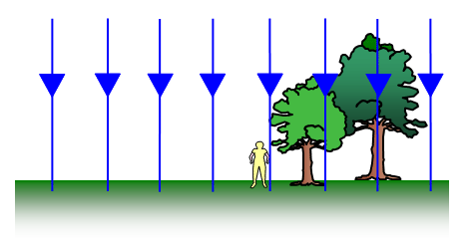

The field lines are taken to be *parallel* and *equally separated*. Hence, the gravitational field strength is *uniform* and approx. *g*=9.81 m s-2.

Fig. 7.3

Fig. 7.2

Fig. 7.5

Fig. 7.4

Reference : <http://www.schoolphysics.co.uk/age16-19/Mechanics/Gravitation/>

|  |
| --- |
| **7.3 Gravitational Force ; Newton’s Universal Law of Gravitation** |

*(b) recall and use Newton's law of gravitation in the form *

|  |
| --- |
| Newton’s universal law of gravitation states that every particle attracts every other particle with a gravitational force that is *directly proportional* to the *product of the masses* and *inversely proportional* to the *square* of the separation between their centres. |

*F12*

*F21*

*m1*

*m2*

*r*

where the gravitational constant,

*G* = 6.67 × 10-11 N m2 kg-2.

Fig. 7.6

If two point masses *m1*and *m2* are separated by a distance *r* , the magnitude of the gravitational force *F* between them is given mathematically by

…………………. Eqn. 7.1

**Characteristics of Gravitational Force:**

1. The gravitational force is a *long-range force* and it exists between any two masses regardless of the medium that they are in. It is the weakest compared to other types of forces eg electromagnetic force.

2. They are always attractive in nature and the pair of forces always act along the line joining the centres of the two masses. Gravitation force is an example of an ‘action-at-a-distance’ or non-contact force.

3. Note that ‘*r’* represents the *separation* between the point masses. ‘*r’* does not necessarily means the radius of orbit.

Newton realized that gravitation is *universal*. Any two masses exert a force of attraction between them. Johannes Kepler who measured the motion of planets in the Solar System forty years earlier observed that the ratio *r*3 / *T*2 were the same for all the planets. Thus, Kepler’s 3rd law states that the square of the period *T* of any planet is directly proportional to the cube of the average radius *r* of its orbit. The table below shows this to be true.

|  |  |  |  |  |  |  |
| --- | --- | --- | --- | --- | --- | --- |
|  | Mercury | Venue | Earth | Mars | Jupiter | Saturn |
| Average radius *r* of orbit / 1010 m | 6 | 11 | 15 | 23 | 78 | 143 |
| Time *T* for one orbit / 107 s | 0.8 | 1.95 | 3.2 | 5.9 | 37.4 | 93.0 |
| *r*3 / *T*2 / 1016 m3 s-2 | 337 | 350 | 330 | 349 | 340 | 338 |

<http://hyperphysics.phy-astr.gsu.edu/hbase/kepler.html>

To investigate Kepler’s 3rd law, Newton assumed that the planets and the Sun were point masses and apply the ‘inverse-square law’ for the gravitational field in the Solar System.

Gravitational

Force ***F***

Velocity *v*

Planet of

mass *m*

Sun of

mass *M*

*r*

Centripetal force 

Gravitational force 

Fig. 7.7

Since the gravitational force provides the centripetal force for the planet to orbit the Sun, we have *F* = *Fc*

[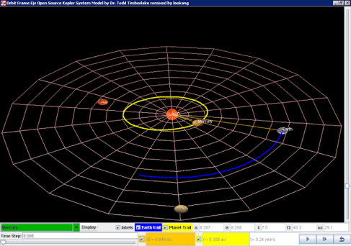](http://3.bp.blogspot.com/-S_q8YEhuDY8/UTmd80kMeEI/AAAAAAAATK8/AI_qmYz1Uts/s1600/kepler_2013-03-08_1614.png)  ⇒ 

Fig. 7.3



Kepler’s Law is a direct consequence of the *inverse-square relation* and thanks to Newton it was verified! Download the Java Simulation to explore further this phenomenon.

<https://dl.dropbox.com/u/44365627/lookangEJSworkspace/export/ejs_KeplerSystem3rdLaw03.jar>

(may need to copy URL to a browser to download)

**Example 1 (N84/P2/Q7) Binary Stars**

Two stars of equal mass *M* move with constant speed *v* in a circular orbit of radius *R* about their common centre of mass. What is the net force on each star?

*v*

*v*

*R*

**A** *GM2/4R2* **B** *Mv2/2R* **C** zero

**D** *2Mv2/R* **E** *GM2/R2*

*The net force acting on each star is the gravitational force.*

* ; * Ans: **A**

*This highlights the point that the ‘r’ in does not represent the radius of orbit but the separation.*

*The forces between the stars are action-reaction pair and they acts on different bodies. Thus, they cannot cancel each other. Each star is an unbalanced system because there is a centripetal force acting on it.*

**Example 2 (N09/I/16) Binary Stars**

*x*

*x*

**O**

*2M*

*M*

Two stars of mass *M* and *2M*, a distance *3x* apart rotate in circles about their common centre of mass **O**.

The gravitational force acting on the stars can be written as .

What is the value of *k* ?

**A** 0.22 **B** 0.50 **C** 0.67 **D** 2.0

⇒ *k* = 2/9 = 0.22 Ans : **A**

**Example 3 (N97/I/7) Inverse-square relation**

A satellite has a weight *W* when assembled before launching. It is placed in a circular orbit at a height *h* = 6*R* above the surface of the Earth of radius *R*. Determine the gravitational force, in terms of *W* acting on the satellite while in orbit.

**A  B  C  D **

*The weight of the satellite is the gravitational force acting on it by the Earth.*

*On Earth’s surface, r = R, W=* --- (1)

*In orbit, r = 7R, Wnew =* --- (2)

* * ⇒ ** Ans : **D**

|  |
| --- |
| **7.4 Gravitational Field Strength** (Symbol : *g*) |

*(a) show an understanding of the concept of a gravitational field as an example of field of force and define gravitational field strength as force per unit mass.*

*(c) derive, from Newton's law of gravitation and the definition of gravitational field strength, the equation for the gravitational field strength of a point mass.*

*(e) show an appreciation that on the surface of the Earth, g is approximately constant and equal to the acceleration of free fall.*

Consider two satellites of different masses (*m*1 > *m*2) orbiting round the Earth with the same radius.

*m*2

*m*1

*r*

*M*

*F*1

*F*2

⇒

⇒

Fig.7.8

At the same separation, the forces on the test masses (*F*2>*F*1) may be different but the *gravitational field strength* on each is the same (*g*1 =*g*2)

Thus to make comparison between the ‘strengths’ for the gravitational force fields at different locations, we need to standardize it by dividing the gravitational force acting on the test object by its own mass (ie to get the *force per unit mass*). That way, the gravitational field strength for a particular spot would be the same regardless of the mass of the object placed there.

(The concept is similar to ‘electric field strength’ which is defined as ‘force per unit positive charge’).

|  |
| --- |
| The *gravitational field strength* (*g*) at a point is defined as the gravitational force **per unit mass** acting on any particle placed at the point.    …………………. Eqn. 7.2 (derivation is required by syllabus) |

**Characteristics of Gravitational Field Strength (*g*):**

1. *g* is a vector quantity and the SI unit for *g* is N kg-1 (or m s-2). The sign +/- depends on the direction.

2. The symbol chosen for the gravitational field strength is ‘*g*’. So far, in kinematics, we have been using *g* to represent the *acceleration due to free-fall* on the Earth’s surface which has the value 9.81 m s-2.

But the generic gravitational field strength ‘*g’* is not necessarily 9.81 N kg-1 (which is the value of *g* on Earth’s surface). Its magnitude varies with distance *r* and mass *M* according to Eqn. 7.2.

To avoid misrepresentation, we will use the symbol, *gE*  to specifically represent the gravitational field strength at the Earth’s surface (ie *gE =* 9.81 N kg-1).

**Mass and Weight** (SI units are ‘kg’ and ‘Newton’ respectively)

Mass is the amount of matter that an object has. The mass of an object remain the same in whatever gravitational field it is in. However, the weight of an object is dependent on its mass and the gravitational field strength that it is placed in. Based on the definition for ‘*g*’,



Thus, we have *W = mg*

Based on Newton’s 2nd law, we have *F = ma*

Ignoring air resistance, the gravitational force exerted by the Earth on an object will cause it to accelerate with the amount equals ‘*a*’. This acceleration is called ‘*acceleration due to free-fall’*.

By association, *W* = *F*

*mg = ma*

*g =a*

Thus, the *acceleration due to free-fall* at a point in the gravitational field is numerically the same as its *gravitational field strength*. Thus, *g* can have the units N kg-1 or m s-2.

And specific to the region near the Earth’s surface, we have

the *gravitation field strength* near the Earth’s surface (*gE*) = 9.81 N kg-1

and the *acceleration due to free-fall* near the Earth’s surface (*gE*) = 9.81 m s-2

However, there might be small variation to the above values due to the following reasons.

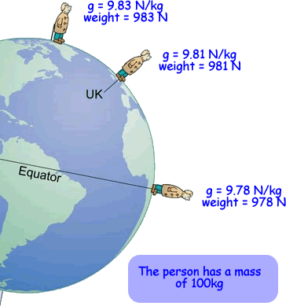

Fig. 7.9 The apparent weight varies with latitude

1. The Earth is not a perfect sphere. The Earth’s radius at the poles is smaller than that at the equator. The value of *gE* is greater at the poles as it is nearer to the dense core of the Earth.

2. The Earth’s surface is not uniform. Higher altitudes will give rise to slightly smaller values of *g* as *r* increases.

3. The density of the Earth varies from region to region beneath the Earth’s surface.

4. The Earth is spinning about its own axis. This will reduce the value of the *apparent weight* especially at the equator where the apparent weight of an object there is the lowest.

*r* / m

*g* / N kg-1

O

*RE*

*Earth*

*M*

*g* is a vector quantity, hence the +/- sign denotes its direction.

*g* follows an inverse-square law

*RE*









*g* is negative because the field line acts to the left.

*g* is positive because the field line acts to the right.

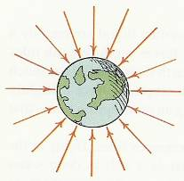

Fig 7.10 The variation of the gravitational field strength (*g*) with distance *r*.

**Example 4 (N2011/I/15) gravitation field strength**

In this question, you can consider all the mass of the Earth to be concentrated at its centre. Work to five significant figures using the following data.

Mass of Earth = 5.9768 × 1024 kg

Distance of Singapore from centre of Earth = 6.3782 × 106 m

Gravitational constant *G* = 6.6730 × 10-11 N m2 kg-2

What is the value of g, the gravitational field strength of the Earth, in Singapore?

**A** 9.8038 N kg-1 **B** 9.8067 N kg-1 **C** 9.8100 N kg-1 **D** 9.8879 N kg-1

**Answer : A**

**Example 5**

Consider a coconut at the top of a tree, pulled by the Earth’s gravity with a force of 10 N. If the tree is twice as tall, what would be the force of gravity on the same coconut?

LNDSC003

LNDSC003

**A** 20 N **B** 10 N **C** 5 N **D** 2.5 N

*Ans :* **B***, because the coconut at the top of the taller tree is not twice as far from the Earth’s centre as the first tree. The change in distance is negligible compared to the radius of the Earth. The weight is still 10 N as there is little change in g.*

*For the weight to decrease by 1%, any object must be raised 32 km (almost four times the height of Mt. Everest). Therefore, we assume the weight to remains the same when it is near the Earth’s surface.*

**Example 6 (N80/I/3 modified)**

The mass of the Earth is about 80 times that of the Moon, and the radius of the Earth is about 3.7 times that of the Moon. Estimate the gravitational field strength at the surface of the Moon.

**

For Earth: …… (1)

For Moon:  …... (2)

**

**

**Variation of Earth’s gravitational field strength with distance from the centre**

*rE*

*g, gravitational field strength\N kg-1*

O

*r, distance from centre / m*

*Assuming uniform density inside Earth.*

*INSIDE*

*OUTSIDE*

*Obeys inverse square law*

**

*gE= 9.81 N kg-1*

*(or 9.81 m s-2)*

*Earth*

*Obeys proportional law*

**

Fig. 7.11 Variation of gravitational field strength, *g* with distance *r* from centre

|  |  |
| --- | --- |
| For points *inside* the Earth, assuming its density *ρ* is uniform, *g* is *directly proportional* to distance *r* from the centre.  where *V* is the volume of sphere of radius *r*.  (Thus, *g ∝ r* inside Earth) | For points *outside* of the Earth, *g* obeys the *inverse-square law*, where gravitational field strength is given by |

**Example 7 (J95/1/8)** (*g* at the surface of sphere using *directly proportional relation*)

The acceleration of free fall on the surface of the Earth is 6 times its value on the surface of the Moon. The mean density of the Earth is times the mean density of the Moon. If *rE* is the radius of the Earth and *rM*is the radius of the Moon, what is the value of  ?

**A** 1.9 **B** 3.6 **C** 6.0 **D** 10

From

 we have  ⇒ 

∴ ** Ans : B**

**Example 8 (N80/I/3 modified)** (*g* at the surface of sphere using *inverse-square law*)

The mass of the Earth is about 80 times that of the Moon, and the radius of the Earth is about 3.7 times that of the Moon. Estimate the gravitational field strength at the surface of the Moon.

From Eqn. 7.2 

For Earth:  ………. (1)

For Moon: ………. (2)

(2) ÷ (1) 



Based on the above two problems, do you know when to use which relations to solve?

They may seem contradictory but they are essentially of the same concept. The *g* on the surface of a sphere depends on its mass, radius (thus the volume) and density. The choice will depend on what data is provided.

**Example 9 (J76/1/2 modified)**

(a) Sketch the variation of the gravitational field strength from the Earth’s surface to the Moon’s surface. Assumed the direction to the right is positive.

(b) A space capsule is travelling along a line between the Earth and the Moon. Determine the distance *x* from the Earth’s centre at which it is subjected to zero resultant gravitational field strength.

(Consider only the gravitational fields of the Earth and the Moon.)

Learning point:

*g* is a vector qty. When adding them, take note of the direction of the gravitational field strength.

Mass of the Earth *ME* = 6.0 × 1024 kg,

Mass of the Moon *MM*= 7.4 × 1022 kg;

Distance *d* between the centres of the Earth and Moon = 3.8 × 108 m

(a)

Earth

Moon

*gQE*

*gQM*

*g due Earth.*

*It is negative as the direction to the left*

*g due Moon.*

*It is positive as direction is to the right*

*Combined g* = 0

*(Neutral point Q)*

*g*

*x*

*d-x*

*Combined g*

Fig. 7.12

How *g* varies along the line between the Earth and the Moon.

(b) At the neutral point *Q*,  (values are equal and opposite)



⇒  ⇒  ⇒ 

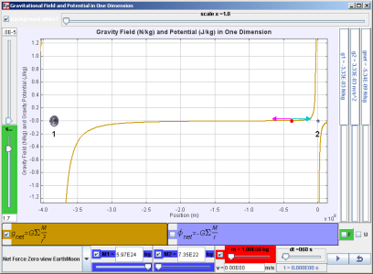⇒  ⇒  = **3.42 × 108 m**

Download the Java Simulation to explore further this phenomenon. <https://dl.dropboxusercontent.com/u/44365627/lookangEJSworkspace/export/ejs_GFieldandPotential1Dv8EarthMoon.jar>

(Need to copy and paste URL on a browser)

|  |
| --- |
| **7.5 Gravitational Potential Energy Revisited** (Symbol : *U*) |

In Topic 5 (W.E.P), the gravitational potential energy (*E*PE) of an object near the Earth’s surface is given as

*E*PE = *mgh*

where *m*= mass of object,

*g* = acceleration of free-fall (ie 9.81 m s-2)

*h* = height of the object above some reference level eg the ground

However, this formula comes with certain limitations.

(1) This formula is restricted for use when the object is near the Earth’s surface because *g* = 9.81 m s-2 is assumed to be constant. However, when the object is displaced much further from the Earth’s surface such as a satellite, *g* will vary with distance from the Earth’s centre.

(2) This value *E*PE of an object is not an absolute value but a relative one. It would be more accurate to say the *change* in the GPE of an object when it is elevated than to say the GPE that it possesses. See Fig. 7.13.

(3) The GPE of an object even at the same level can be different because the reference level is different. Thus, it would be more accurate to rewrite the above equation as Δ *E*PE = *mgΔh* in which case the reference level would not matter.

(4) An object placed at an infinite distance away from the Earth will have the gravitational force on the object approaching zero (*r* →∞, *F*→0). In this topic, we shall take the reference point to be at infinity where its GPE is nearly zero. We will use the symbol *U* to represent the absolute GPE of an object where the reference point is taken to be at infinity (*U*∞ = 0).

Using this as reference level

*H* = 2.5 m

*h* = 0.50 m

Using this as reference level

*m=1.0 kg*

*m=1.0 kg*

*E*PE*= m gE H*

*= (1.0)(9.81)(2.5)*

= 24.5 J

*E*PE*= m gE h*

*= (1.0)(9.81)(0.50)*

= 4.91J

*bookshelf*

Fig. 7.13 The value for the GPE of the same object depends on the reference level.

**The concept of Positive and Negative work done by an external agent**

Fig. 7.14a : Positive W.D. by external agent in *raising* the object

WD = *Fx cosθ = mgx cos*0o *= + mgx*

The object gains GPE. ∴Positive WD.

Fig. 7.14b: Negative W.D. by external agent in *lowering* the object

WD = *Fx cosθ = mgx cos*180o *= - mgx*

The object loses GPE. ∴Negative WD.

*Displacement x*

*Force F by external agent*

*Displacement x*

*Force F by external agent*

*m*

*m*

Recall from Topic 5, work done (WD) on an object by an external agent is given by the product of the force applied on it and the parallel displacement. (WD = *Fx cosθ* )

In lifting an object, the external agent (eg a person) does *positive work* because the force by the external agent and the displacement of the object are in the same direction. Fig. 7.14a. Thus, the object gains GPE.

In lowering an object, the external agent does *negative work* because the direction of the force applied by the external agent and the displacement of the object are in opposite directions. Fig. 7.14b. Thus, the object loses GPE.

In fact, if the person releases the object from rest, the object will naturally fall towards the Earth. The person (external agent) does not need to do any work to bring the object down; it is gravity that does the work.

Now, we will extend the above concept to an object being displaced much much farther away from the Earth’s surface for example to outer space.

Gravitational force is an attractive one. So naturally, to ‘tear’ an object away from the Earth’s surface and bring it to an infinite distance, *positive work* must be done by an external agent to separate them.

Conversely, there is *negative work* done by the external agent when the object is brought from infinity to the Earth’s surface. Note that the focus is on the work done by the external agent not gravity.

|  |  |
| --- | --- |
| **Positive work** is done by an external agent when an object is displaced away from Earth’s centre.  Its GPE will increase | **Negative work** is done by an external agent when an object is displaced towards the Earth’s centre.  Its GPE will decrease. |

In moving towards infinity, the gravitational field strength becomes progressively weaker. So it gets easier to separate oneself from Earth’s pull as one gets further and further away from Earth.

*U*



*RE*

*Force by external agent, F*

*Distance x from Earth’s centre*

**

*Displacement from x=∞ to x=r*

**

**

*mass m of test object*

*M*

*U∞ = 0*

*r*



*Gravitational force is*

*the negative of U-x gradient*

*F*

Fig. 7.15 Variation of gravitational potential energy *U* with distance *x* from the Earth’s centre.

|  |
| --- |
| The **gravitational potential energy** (*U*) of a mass *m* at a point (due to the gravitational field set up by mass *M* ) is the work done by an external agent in bringing the mass from infinity to that point. |

The change in WD (or Δ*U*) of an object by a small displacement Δ*x* is given by

Δ*U* = *F*Δ*x*

*Rearranging F =* Δ*U* /Δ*x. So the gradient of the U-x graph is numerically equals to the gravitational force.*

From the definition above, to find the absolute GPE of a test object in a gravitational field, we need to apply integration to Δ*U* = *F*Δ*x* from *x=∞* to *x=r.*

 =  (where *r* is the distance of the test object from centre of mass *M*)

=  = =  = 

 …………………. Eqn. 7.3

**Characteristics of Gravitational Potential Energy (*U*):**

1. *U* is a scalar quantity with SI unit of joule (J).

2. The GPE *U* is a property of the *M*-*m* system. The gravitational force acting on an object is given by the *negative gradient* at a point in the *U-r* graph. 

For example,  is positive at a point on the graph in Fig. 7.12. but *F* is negative because the direction of *F* is to the left.

3. The GPE *U* is an *absolute value* and it has its reference point at infinity where *U∞* = O.

4. *U* at infinity is taken to be zero because when the test object of mass *m* is separated by a very large distance from the mass *M*, the gravitational force tends to zero. (*x* → ∞, *F*→ 0, *U* → 0). Thus when the two bodies are separated by a very large distance, there is negligible GPE in the *M-m* system.

5. The negative sign in Eqn. 7.3 does not indicate direction but its value in relation to the gravitational potential energy at infinity which is zero. At distance less than infinity, the absolute value for *U* is always negative. Note, the value of *U* increases in the direction of increasing *r*.

6. The negative sign in Eqn. 7.3 indicates that *M* and *m* is a **bound system** ie *M* and *m* has a mutual attractive force for each other. To separate them, one must do positive work for example in moving the test object from *x=r* to *x*=∞ to overcome the gravitational force. For example, if the GPE of a *M-m* system is -100 J; it means 100 J is needed to separate them completely. When they are separated at an infinite distance apart, the GPE of the system equals to zero.

\*The negative sign in Eqn. 7.3 indicates that the work done by an external agent is negative as the displacement of the test object from infinity to the point concern is in opposite direction to the application of the force by the external agent. As the *GPE at infinity is zero*, the GPE of a body at points less than infinity will have *negative* values**.**

**Example 10 (N2008/1/13)**

A satellite of mass *m* is moved from a circular orbit of radius *r*1 around the Earth to a new circular orbit of radius *r*2 as shown. The mass of the Earth is *M* and the gravitation constant is *G*.

*r*2

*r*1

*satellite mass m*

*Earth mass M*

What is the increase in the potential energy of the satellite?

**A** **B**

**C** **D**

*Solution*

*The GPE at r2 is greater than that at r1.*

*Increase in GPE =*

*=* **Answer : D**

**Example 11 (J88/1/18)**

*3R*

*R*

**P**

Moon

A stationary object is released from a point *P* a distance *3R* from the centre of the Moon which has a radius *R* and mass *M*.

Which one of the following equations gives the speed of the object on hitting the Moon?

**A**  **B**  **C**  **D** 

Hint: You cannot use  but you can still use the Principle of Conservation of Mechanic Energy (C.O.M.E.).

Sum of KE and GPE of object at Moon’s surface = Sum of KE and GPE of object at P



 **Ans : B**

**Escape Speed**

“*What goes up must come down*”. Does this saying apply for all cases? Not so, if the object, for example, a rocket is fired from the Earth’s surface with a very large speed such that the rocket just escapes from the gravitational influence of the Earth. When the rocket is at an infinite distance, the gravitational force on it is approaching zero.

|  |
| --- |
| The ***escape speed*** for an object at the Earth’s surface is the *minimum* speed it must have to escape from the gravitational influence of the Earth. |



Fig. 7.16 Projecting a test object of mass *m* with escape speed.

To just ‘break away’ from Earth’s gravitational force, the object of mass *m* needs to be brought from the surface of Earth (mass *ME* and radius *RE*) to infinity.

To do so, mass *m* is given a certain initial KE. As it travels away from the Earth, its KE decreases while its GPE increases. When at the edge of the ‘**PE well’**, the mass has almost zero KE.

Using the principle of conservation of (mechanical) energy for the test object of mass *m,*





Escape speed , ………….. Eqn. 7.4

At times, *ME* is not provided. Then, we must make use of the fact that at or near the Earth’s surface,



⇒  .………….. Eqn. 7.5

On substituting into Eqn. 7.4,

Escape speed , 

Escape speed ,  *v* =  ………….. Eqn. 7.6 (*R*E : Radius of Earth)

(*g*E: 9.81 N kg-1)

Note:

1. The escape speed is independent of the mass of the test object. That is, the escape speed from a certain planet is the same whether the object is a big rocket or a small golf ball.

2. The escape speed from Earth is about 11.5 km s-1 while that from the Moon is 2.4 km s-1. The ‘average’ velocity for air molecules at room temperature and normal pressure is about 500 m s-1. Because the air molecules move with an average speed less than the escape speed, there is an atmosphere round the Earth. The Moon does not have an atmosphere because of its much smaller ‘escape speed’.

**Example 12 (N79/1/1)**

The speed with which a body should be projected from the Earth’s surface in order to reach infinite distance is about 1.1 × 104 m s-1. Estimate the speed of escape from the Moon.

Mass of Earth / Mass of Moon = 81

Radius of Earth / Radius of Moon = 3.7

From Eqn. 7.5, for the Earth,  ………….. (1)

for the Moon,  ………….. (2)

(2)÷(1) 

= 2.4 ×103 m s-1

**Example 13 (N83/2/8)**

The escape speed (i.e. the speed which a body must have in order to escape to an infinite distance from the Earth) of an oxygen molecule at the Earth’s surface is 1.1 × 104 m s-1.

What is the escape speed at a height 0.20 *RE*above the Earth’s surface, where *RE* is the radius of the Earth?

**A** 0.5 × 104 m s-1 **B** 1.0 × 104 m s-1 **C** 1.1 × 104 m s-1 **D**  1.2 × 104 m s-1

To escape to infinity : GPEX + KEX = GPE∞ + KE∞  (Principle of C.O.M.E.)

From Earth’s surface, 





From a height of 0.2 *RE* above the Earth’s surface,





*v* = 1.00 × 104 m s-1 **Answer : B**

|  |
| --- |
| **7.5 Gravitational Potential** (Symbol : *φ pronounced as ‘phi’*) |

*(f) define potential at a point as work done in bringing unit mass from infinity to the point.*

*(g) solve problems using the equation  for the potential in the field of a point mass.*

The GPE *U* at the point in the gravitation field is specific to the test object and its value depends on the mass of the test object. However, to standardize the property of the gravitational field, we must take the GPE *per unit mass* of the test object. This quantity is called *gravitational potential* (*φ* )

|  |
| --- |
| The **gravitational potential** (*φ* ) at a point due the gravitational field (set up by a mass *M*) is the work done *per unit mass* by an external agent in bringing the mass from infinity to that point. |



 …………………. Eqn. 7.7 (where *r* is the distance of the point to centre of mass *M*)

**Characteristics of Gravitation Potential, *φ*:**

1. Gravitational potential *φ* is a scalar quantity with SI unit of J kg-1. The negative sign for *φ* does not represent direction but its absolute value relative to *φ* = 0 at infinity.
2. The negative sign denotes that the two body system is a bound system and to separate them completely, the work done per unit mass is *GM/r*
3. Notice when the separation approaches to infinity, the value for the gravitational potential approaches zero (*r*→∞, *φ*→0)

*x* / m

*φ* / MJ kg-1



*RE*



-60

-50

-40

-30

-20

-70

-20 MJ kg-1

-30 MJ kg-1

-40 MJ kg-1

-10 MJ kg-1

*M*

*Grav. field lines*

*Equipotential lines/surfaces*

*The field lines must always be perpendicular to the equipotential lines.*

*The field lines always acts in the direction of decreasing gravitational potential.*



*gravitational field strength is*

*is the negative of the potential gradient*

Fig. 7.17 Variation of gravitational potential *φ* with distance *x* from centre of mass *M*.

Above the graph are equipotential curves (or surfaces) and gravitational field lines due to Earth.

The diagram represents a ‘*gravitational* *potential well’*.

The gravitational potential sinks when approaching Earth.

1. **Equipotentials** are lines or curves of constantpotential. There is no work done on an object when moving along an equipotential line or surface because there is no change of potential.
2. The *equipotential lines* resemble the contour lines used in topography. The closer the equipotential lines, the greater the gravitational field strength (or potential gradient). Fig. 7.17 has concentric equipotential circles which separate further apart as *r* increases from the Earth. This means that *g* decreases with increasing *r*. The change in gravitational potential (Δ*φ* ) or GPE (∆*U*) is independent of the path taken by object. The change in gravitational potential or gravitational potential energy depends only on the start and end points.
3. The *potential gradient* is numerically equals to the gravitational field strength. 
4. The potential gradient decreases with increasing *r*.
5. The *minimum work done per unit mass* to remove an object out of a potential well due to the Earth is . At the edge of the potential wall, ie *r*→ ∞ , the gravitational field strength is practically zero. So here, the object just managed to overcome the gravitational pull of the Earth.
6. The gravitational field always points in the direction of decreasing gravitational potential.

For more about Gravitational Potential Well : <http://en.wikipedia.org/wiki/Gravity_well>

**Example 14 (N98/1/7)**

*r*

**P**

**Q**

A mass *m* is at fixed point **Q**. It produces a gravitational potential at point **P**, distance *r* from **Q**. The gravitational potential is equal to the external work done on unit mass in moving it

**A** from **P** to **Q C** from **P** to infinity

**B** from **Q** to **P D** from infinity to **P** **Ans : D** (by definition)

**Example 15 (N2006/1/10)**

O

S

An astronomical gas cloud has a mass M and radius R. The gravitational potential on its surface S is –GM/R and at its centre O it is -3GM/2R.

A unit mass is moved slowly by means of an external force from the surface S to the centre O. What is the work done on the mass by the external force?

**A**  **B**  **C**  **D**

The gravitational potential at O is lower than that at S. Thus, negative work is done by the external agent.

Work done = *φ*final - *φ*initial = *φ*O - *φ*S

**= Answer : B**

**Example 16 (N99/1/7) Modified**

A satellite of mass 50 kg moves from a point where the gravitational potential due to the Earth is – 20 MJ kg-1 to another point where the gravitational potential is – 60 MJ kg-1.

(a) Does the satellite move closer to or further from Earth?



The initial gravitational potential – 20 MJ kg-1 greater than final gravitational potential – 60 MJ kg-1. The gravitational field is always in the direction of decreasing gravitational potential. Since the gravitation potential becomes more negative as the object approaches the Earth, the satellite must be moving closer to the Earth.

(b) What is its change in potential energy?



⇒  = *m (φf - φi)*

= 50[(-60)-(-20)]× 106

= -2.0 × 109 J (Negative sign indicate a loss in GPE)

(c) Calculate the magnitude of the average gravitational field strength between these two points given that they are separated by a distance 1.33 × 107 m.



|  |
| --- |
| * 1. **Relationship between gravitational force and GPE gradient**   **& gravitational field strength and gravitational potential gradient** |

(See Breithaupt, 4th Ed, page 225-226)

*dU*

*M*

*r* = ∞

*F*

*Fext*

Fig. 7. 18

*dr*

Given that  (positive work done by external agent)



But  ⇒  ………….. Eqn. 7.8

Thus ***F* is the negative of the potential energy gradient** (i.e. negative gradient of *U*-*r* graph)

Dividing by mass *m*:  ⇒  ………….. Eqn. 7.9

Thus, ***g* is the negative of the potential gradient** (i.e. negative gradient of *φ*-*r* graph)

The negative sign in both equations 7.8 and 7.9 is to ensure consistency in the mathematical equations. When moving a test object in the direction of increasing *r*, the GPE and gravitational potential also increase.

The gravitational force and gravitational field strength always act in the direction of decreasing gravitational potential.

**Example 17 (J89/II/2 (part))**

-62.72

-59.12

-59.03

-58.94

*φ* / MJ kg-1

*x/ m*

*The potential gradient across neighbouring points is an estimate of the grav field strength in between.*

Values for the gravitational potential due to the Earth are given in the table below.

|  |  |
| --- | --- |
| Distance from  Earth’s surface / m | Gravitational  potential / MJ kg-1 |
| 0  390 000  400 000  410 000  Infinity | -62.72  -59.12  -59.03  -58.94  0 |

|  |  |
| --- | --- |
| 1. If a satellite of mass 700 kg falls from a height of 400 000 m to the Earth’s surface, how much potential energy does it lose?   *∆U = mΔφ*  = 700×[(-62.72)-(-59.03)]×106  = - 2.58 × 109 J  Loss in GPE = 2.58 × 109 J | 1. Deduce a value for the Earth’s gravitational field at a height of 400 000 m.     =  = 9.0 N kg-1 |

**Example 18 (N93/1/5)modified**

The diagram below represents the relative positions of the Earth and the Moon. The line ***XY*** joins the surface of the Earth to the surface of the Moon. The variation of the gravitational potentials due to the Earth and the Moon separately are indicated below. Draw the variation along the line ***XY*** of the

(a) combined gravitational potential *φ*

(b) combined gravitational field strength *g*.

*Combined φ*

*Combined g*

*Earth*

*Moon*

*At Neutral Point*

⇒ *g = 0*

⇒ *φ = Max*

*X*

*Y*







Learning point

From the graph, why is it easier to launch a rocket from the Moon to the Earth than vice versa?

Fig.7.19

How the net gravitational potential varies along the line between the Earth and the Moon.

Think of the above graph as two ‘potential wells’ placed side by side. One for the Earth and the other for the Moon.

The well associated with Earth is deeper as its mass is larger. Thus, to ‘climb out’ of it requires more work.

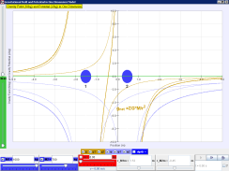

Download Java Simulation “Gravitation Potential 1 Dimension”

<https://dl.dropbox.com/u/44365627/lookangEJSworkspace/export/ejs_GField_and_Potential_1D_v7wee.jar>



Download Java Simulation “Gravitation Potential 1 Dimension Earth and Moon Real Data”

<https://dl.dropbox.com/u/44365627/lookangEJSworkspace/export/ejs_GFieldandPotential1Dv7EarthMoon.jar>

**Apollo 13 (1995 Movie based on Book “Lost Moon” by James A. Lovell)**

<http://en.wikipedia.org/wiki/Apollo_13>

<http://en.wikipedia.org/wiki/Apollo_13_(film)>

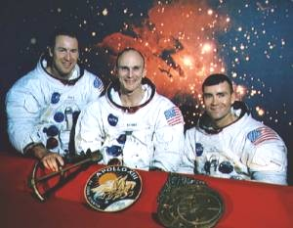<http://echoesofapollo.com/2009/12/20/apollos-re-entry-window/>

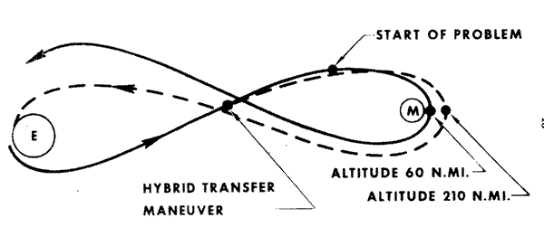

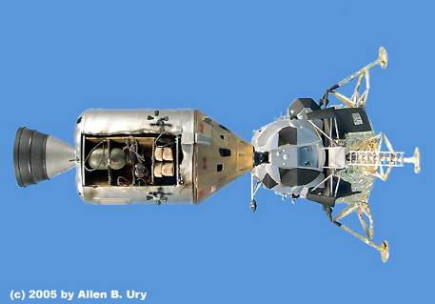

Lunar Module

Command Module

Why is the path of the module a figure 8?

Watch Video : <http://www.youtube.com/watch?v=s7JUQNpHYtg&feature=related> [from Apollo 13 the movie]

|  |
| --- |
| **7.7 Gravitational field due to a point mass and electric field due to a point charge.** |

*(h) recognize the analogy between certain qualitative and quantitative aspects of gravitational and electric fields.*

Gravitation field and electric field due to a point mass and a point charge respectively share many similar characteristics. They will be studied more closely later after learning the topic of electric field. Suffice for now, to know that both obey the inverse-square rule.

|  |
| --- |
| **7.8 Circular Orbit and Satellite Motion** |

*(i) analyse circular orbits in inverse square law fields by relating the gravitational force to the centripetal acceleration it causes.*

<http://www.physicsclassroom.com/Class/circles/> [Good resource]

<http://www.mtholyoke.edu/courses/mdyar/ast223/orbits/orb_lect.html> [Kepler’s laws]

<http://www.surendranath.org/Applets/Dynamics/Kepler/Kepler3Applet.html> [Good Applet]

Johannes Kepler (1571-1630) stated in his 3rd law of planetary motion that the square of the orbital period *T* of any planet is proportional to the cube of the average distance *R* from the planet to the Sun.

……………. Eqn 7.10

Kepler noted a directly proportional relationship between *T*2 and *R*3 for the planets in the solar system but provided no explanation for it. Many years later, Newton verified Kepler’s findings using his famous inverse square gravitational field law. Because the orbits of the planets around the Sun are very nearly circular, we can use the formula for centripetal force and apply it to the gravitational force. However, it should be noted that most orbits are elliptical in shape eg comets and asteroids.



Fig. 7.20 Gravitational force provides the centripetal force necessary for the circular orbit.

Centripetal force 

Gravitational force 

**Note that circular motion is not a balanced system because there is centripetal acceleration present.**

As the source of the centripetal force is the gravitational force,



1. To find the orbital linear speed *v* of the planet,

**Gravitational force = Centripetal force** [*Good practice to write this line before your calculation*]

 ⇒ 

2. To find the angular velocity *ω* of the planet,

 ⇒ 

The above equations also apply to satellites orbiting the Earth as their orbits are circular.

**Example 19 (N2008/1/14)**

The radius of the Earth’s orbit about the Sun is 1.50× 1011 m. The Earth takes 365 days to orbit the Sun. What is the mass of the Sun?

**A** 6.40 × 1029 kg **B** 2.01 × 1030 kg **C** 1.16 × 1033 kg **D** 3.31 × 1033 kg



= 2.01 × 1030 kg **Answer : B**

**Example 20 (N94/1/8)**

A communications satellite which takes 24 hours to complete one orbit is replaced by a new satellite which has twice the mass of the first.

If the new satellite also has an orbit time of 24 hours, then the ratio **?**

**A  B  C D  E**

From , the period is independent of the orbiting mass. Since, the period is unchanged, the radius is the same. **Answer : A**

**Example 21**

A communications satellite orbits the Earth in a circle of radius 9000 km. At that distance, *g* = 4.9 m s-2. The speed of the satellite is

Centripetal acc, *ac = g*

**

**

= 6640 m s-1 **Ans : A**

**A** 6.6 km s-1

**B** 8.9 km s-1

**C** 8.4 km s-1

**D** Not possible to determine without

knowing the mass of the satellite.

**Satellites**

*(j) show an understanding of geostationary orbits and their application.*

<http://en.wikipedia.org/wiki/Satellite>

<http://www.satellites.spacesim.org/english/engineer/copy/index.html> [Types and uses of satellites]

<http://science.howstuffworks.com/satellite6.htm> [Types of satellite orbits]

A satellite is an object which orbits round a planet or a star. There are natural satellites such as the Moon and artificial satellites put there by humans.

The first artificial satellite, the Sputnik 1, was launched by the Soviet Union in 1957. Since then, hundreds of satellites have been launched into orbit around the Earth. Satellites are used for various purposes.

Common types include military and civilian Earth observation satellites (eg for Google Maps and outer-space observation eg Hubble Space telescope), communications satellites, navigation satellites (eg GPS), weather satellites, and research satellites (eg recording changes in land erosion over a period of time).

The radii of the satellite orbits are not all the same and depend on the purpose of the satellite. Well-known orbits include low Earth orbit, polar orbit, and geostationary orbit.

Fig. 7.21 Satellites and their orbital paths



**equator**

Northern Hemisphere

Southern Hemisphere

**Geostationary orbit**

(about 36,000 km above Earth’s surface)

Mainly for telecommunication,

Asynchronous

Satellite (eg GPS)

**Polar Orbit or Low Earth Orbit**

(600-2000 km above Earth’s Surface)

Mainly for navigation (GPS), weather forecast and closer up aerial view of the Earth. A string of 12 satellites lie in a polar orbit.

Geosynchronous or geostationary

satellite

Asynchronous

orbit

Polar orbit

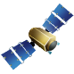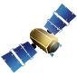

**Geostationary Satellites**

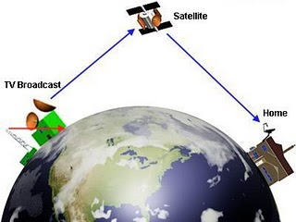

**A geostationary satellite is an orbiting satellite that is *always* positioned directly above the same spot on the Earth’s equator at all times.**

As it always appear stationary to an observer on the Earth's surface, the satellite is said to be in a *geostationary orbit* or a ‘*parking’ orbit*. There is only one orbital plane and one radius in which a satellite can be *geosynchronous*. To have a 24 hour orbital period, they must keep at an orbital altitude of 35,780 km or about 5.61times Earth radii. Radius of orbit is 6.61 times Earth radius.

**A geostationary satellite must satisfy the following 3 conditions**

**1.** The orbit of the geostationary satellite must lie on the **equatorial plane**.

*If the circular orbit is not on the equatorial plane, the satellite would sometimes be over the northern hemisphere and sometimes over the southern hemisphere. This would not be a geostationary orbit.*

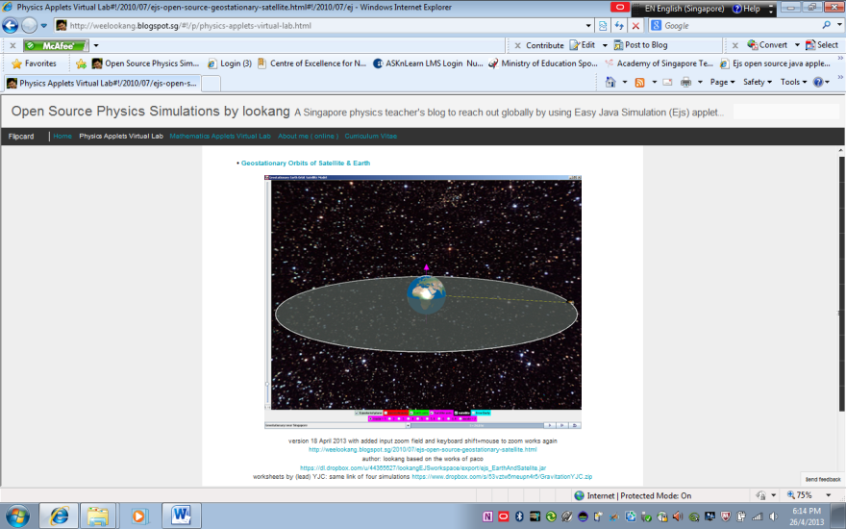

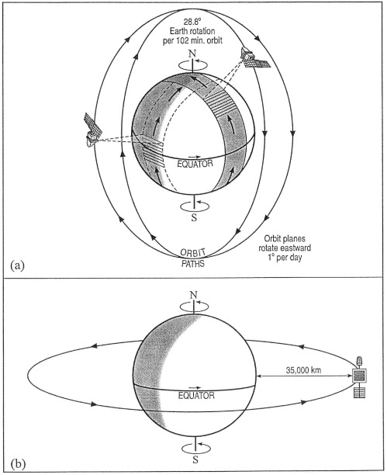

Try out the simulation on geostationary satellite

<http://weelookang.blogspot.sg/#!/2010/07/ejs-open-source-geostationary-satellite.html>

**2.** The orbital period of the satellite must be the same as the period of the rotation of the Earth about its own axis, i.e. **24 hours**.

*Note: Since the period T is only dependent on the radius r of the circular orbit, satellites on the geostationary orbit must have the same radius of rotation in order for them to complete one revolution around the Earth in 24 hours. It is about 35 780 km above the Earth’s surface.*

* 1. The satellite must travel in the same direction as the spinning of Earth about its own axis, moving from the **West to the East**.

**Advantages and disadvantages of geostationary satellites:**

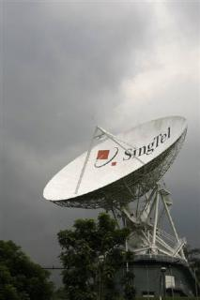*Advantages*:

1. A geostationary satellite remains ‘stationary’ above the same spot on the Earth’s surface at any time and so it is ideal for telecommunication purposes. A permanent line of ‘sight’ between the transmitter and the receiver via the satellite allows for uninterrupted telecommunication.

2. No need to constantly track the satellite as it is always at the same relative position above the Earth’s surface. Thus, there is no need to keep adjusting the direction of the satellite dish to receive telecommunication signal from a particular geostationary satellite.

3. As geostationary satellites are positioned at a high altitude (a distance of 3.6 × 107 m away from the surface of the Earth), it can view the whole Earth below them, rather than a small subsection and they can scan the same area frequently. Hence, they are ideal for meteorological applications and remote imaging.

*Disadvantages*:

1. As geostationary satellites are positioned at such a high altitude, the spatial resolution of the images of the Earth’s surface captured by them may not be as good as those captured by the low orbiting satellites.

2. Because of its high altitude also, there may be a delay in the reception of the telecommunication signals resulting in a lag time especially when conducting international video conferencing.

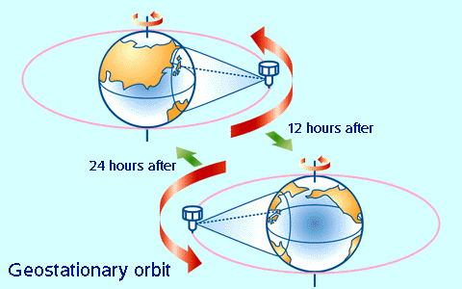3. There is limitation to the geographical coverage, since ground stations at latitudes higher than 60 degrees would have difficulty reliably receiving signals at low elevations. Satellite dishes at such high latitudes would need to be pointed almost directly towards the horizon. The signals would have to pass through the largest amount of atmosphere, and could even be blocked by land topography, vegetation or buildings.

The signals received by countries beyond the 60 degrees latitude ‘belt’, both on north and south sides would be rather weak.

Source:

<http://www.newmediastudio.org/DataDiscovery/Hurr_ED_Center/Satellites_and_Sensors/Geostationary_Orbits/Geostationary_Sat.html>

<http://www.sat.dundee.ac.uk/pdusfaq.html>

**Advantages and disadvantages of low altitude orbit satellites (eg polar orbit):**

Satellites in polar orbits circle the Earth over the poles in a constant plane while the Earth rotates beneath them. Satellites in this type of orbit can view only a strip of Earth's surface on each orbit. Strips of images must be "stitched together," to produce a larger view. Polar satellites has a much [lower altitude](http://www.weatheronline.co.uk/map/sat/euro/ukuk.htm) (about 850km) providing more detailed information about the weather and cloud formation.

*Advantages*:

1. Due to their lower altitudes, these satellites can capture images of the Earth’s surface with greater spatial resolution. Polar satellites have the advantage of photographing close up images of Earth. Geostationary satellite images of the polar regions are distorted because of the low angle that the satellite ‘sees’ the region with.
2. There is reduced lag time or delay between the transmission and reception of the signal.

*Disadvantages*:

1. No one spot on the Earth's surface can be viewed continuously by any one satellite in a polar orbit. A typical low orbit satellite would take about 2 hr to make one revolution round the Earth. In order to have a continuous relay of data, there must be a series or chain of satellites in the same orbit so that one ‘takes over’ the predecessor’s function as they move along in the orbit.
2. Because the satellite changes its location constantly with respect to the Earth’s surface, the direction of the satellite dish would need to be adjusted constantly as well.

**Example 22 (J2000/1/8)**

Which quantity is not necessarily the same for satellites that are in geostationary orbits around the Earth?

**A** angular velocity

**B** centripetal acceleration

**C** kinetic energy

**D** orbital period

*Kinetic energy is dependent on the satellite's mass and velocity. Hence different satellites in the geostationary orbit may have different kinetic energies.* **Ans: C**

[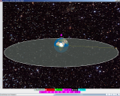](http://1.bp.blogspot.com/-M1XwyqnBWzs/UW-XTjUYSdI/AAAAAAAAU-8/P52VYICqtkU/s1600/geostationary_2013-04-18_1445.png)

Download the Java Simulation “Geostationary orbit of satellites”

<https://dl.dropbox.com/u/44365627/lookangEJSworkspace/export/ejs_EarthAndSatelite.jar>

|  |
| --- |
| **7.9 Total Energy of a Satellite** |

A satellite of mass *m* in orbit with radius *r* around the Earth (mass *M*) has both KE and GPE. We use the following method to find the kinetic energy *K* of a satellite:

Recall for a circular motion, Gravitational force *F* = *FC* = *maC*

 ⇒ 

Thus, the kinetic energy *K*  …………… Eqn 7.11

From Eqn 7.3 on page 13. the gravitational potential energy *U* is given by

 …………… Eqn 7.12

|  |  |
| --- | --- |
| The kinetic energy of the satellite in orbit is negative half of the GPE. | *K = -U/2* |

The total (mechanical) energy *T* of the orbiting satellite is given by

*T = K + U*

 ………… Eqn 7.13

|  |  |
| --- | --- |
| *The total energy of the satellite* is equals to half of the GPE. | *T* = *U/2* |

The negative sign in Eqn 7.13 simply means that the satellite is bound to the Earth. Positive work must be given by an external agent to the satellite in order to break free from the Earth’s gravitational hold.

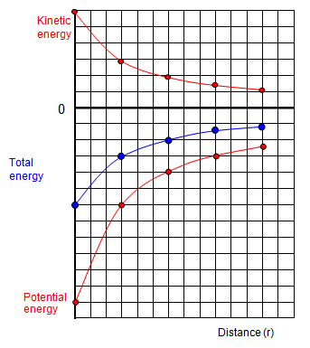

Energy

Distance *r*

*U*

*T*

*K*

**

**

**

Fig. 7.22 *K, U* and *T* of orbiting satellites at various radii.

**

**

**Y**

*K=kinetic energy ; U = Gravitational Potential Energy; T=Total Energy*

Earth

**X**

Download the Java Sim

<https://dl.dropbox.com/u/44365627/lookangEJSworkspace/export/ejs_NewtonsMountainwee.jar>

Assuming there is no dissipative force acting on the system, the total energy of the satellite in a fixed orbital radius would be a constant. Because there is no work done on the orbiting satellite as the gravitational force is perpendicular to the circular path of the satellite, its KE is a constant. The GPE of the satellite would also be constant if it continues to remain in the orbit of the same radius.

But let us consider a satellite at radius X which loses some of its total energy due to friction in the Earth’s atmosphere. The radius of the orbit would decrease gradually as the satellite slowly spiral its way towards the Earth’s surface. What happens to the KE, GPE and Total Energy of the satellite when it descends to a new orbit of smaller radius Y?

As can be seen in Fig. 7.22, the total energy will decrease. Its KE would increase and its GPE will decrease. Friction does not cause the satellite to slow down! The loss in GPE causes an increased in KE just like an object dropped from rest near the Earth’s surface would. The GPE decreases by twice as much as its KE increases and so as a whole, there is a net loss of total energy.

As the satellite re-enters the atmosphere, increasing amounts of thermal energy will be generated due to contact friction on the satellite’s surface as the satellite ‘bull-dozed’ its way across the atmosphere.

**Example 23 (N2009/1/17)**

A satellite orbits a planet at a distance *r* from its centre. Its gravitational potential energy is -3.2 MJ.

Another identical satellite orbits the planet at a distance 2*r* from its centre.

What is the sum of the kinetic energy and the gravitational potential energy of this second satellite?

**A** -0.40 MJ **B** -0.80 MJ **C** -1.6 MJ **D** -6.4 MJ

*Solution*

*At distance r, U = -3.2MJ, Total Energy of the satellite Tr = U/2 = -3.2 MJ /2 = -1.6 MJ*

*It is given that the total energy of a satellite is *

*Since , we have*

*At distance 2r, Total energy at distance 2r =*  × *T*r = × (-1.6) = -0.8 MJ.

**Answer :B**

**Example 24**

An earth satellite of mass 200 kg lost energy slowly through atmospheric resistance and fell from an orbit **P** of radius 8.0 × 106 m to an orbit **Q** of radius 7.8 × 106 m. Calculate the changes in the potential, kinetic and total energies of the satellite during this transition.

(1) To find the change in GPE

**P**

**Q**

Δ*U = UQ –UP*

(always take final amount minus initial amount)



= - **2.57 × 108 J** ⇒ there is a decrease in GPE.

(ii) To find the change in KE

After finding Δ*U*, the rest is easy. We just make use of the relations for *U, K* and *T on pg 27. Fig. 7.22*

Δ*K*  = -Δ*U / 2 =* - (- 2.57 × 108 )/ 2 = **1.28 × 108 J**  ⇒ there is an increase in KE.

(iii) To find the change in total energy *T*

Δ*T* = Δ*U / 2* = - **1.28 × 108 J**  ⇒ there is a decrease in Total Energy.

**Appendix A**

To see the versatility of the equation when used to find the change in GPE for small displacement, consider the following steps of reduction.

The formula for Δ*U* = *mgE h* can be obtained if we assume the displacement *h* is small. 

 = 

*h*

*RE*

*U2*

*U1*

*ME*

*m*





Since , we can drop *h*



Since 



Thus, is more encompassing as it can be used in all circumstances.

***Gravitational Field***

***Summary***

|  |  |  |  |
| --- | --- | --- | --- |
| 1. | Gravitational Force,  (Units : N) |  |  |
| 2. | Gravitational Field Strength,  (Units : N kg-1 or m s-2) |  |  |
| 3. | Gravitational Potential Energy,  (Units : J ) |  |  |
| 4. | Gravitational Potential,  (Units : J kg-1) |  |  |

5. When the satellite is in orbit, the gravitational force provides the centripetal force.



6. If the mass *M* of Earth is not provided, you can make use of the relation,

 ⇒  (where =9.81 m s-2, =radius of Earth)

7. To find the *escape speed* (*ve*) from a planet of mass *M* and radius *R*, use the principle of conservation of energy

8. Kepler’s 3rd law states  ( Note the relation is independent of mass of the orbiting object)

9. For a satellite orbiting in a circular path, its energies are

1. Gravitational Potential Energy 
2. Kinetic Energy 
3. Total Energy 

**End**

**Appendix B**

**Gravitation Enrichment Exercise**

**Self-Directed Learning through Inquiry**

Because of the enormity of the phenomenon, the topic of gravitation is a very abstract and difficult concept to grasp. In addition, to see how gravitational interaction takes place in real time, it is not always practical. Hence, it is appropriate to use Java Simulation to help us visualize the concept and draw connection. In this light, please visit the website

[**http://weelookang.blogspot.sg/**](http://weelookang.blogspot.sg/)

With the June break coming, I would like to encourage all H2 Physics students to attempt this online exercise which will help you in your understanding of the topic. This particular Java Simulation won the Innery Gold Award 2012 and so there are merits to its usage.

<http://weelookang.blogspot.sg/#!/2012/04/gravity-physics-by-inquiry-gold-innergy.html>

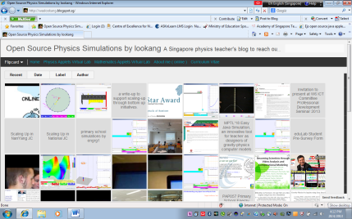These are the steps.

1. Download the Gravitational worksheets from LMS. I will give you a hard copy after the lectures. This serves as a working document.
2. Go to the website below

<http://weelookang.blogspot.sg/#!/p/physics-applets-virtual-lab.html>

1. Scroll down and download the following 5 Java Files listed below.

|  |  |
| --- | --- |
|  | **Java Simulation Files** (the file has the extension “.jar”) |
| [http://3.bp.blogspot.com/-S_q8YEhuDY8/UTmd80kMeEI/AAAAAAAATK8/AI_qmYz1Uts/s640/kepler_2013-03-08_1614.png](http://3.bp.blogspot.com/-S_q8YEhuDY8/UTmd80kMeEI/AAAAAAAATK8/AI_qmYz1Uts/s1600/kepler_2013-03-08_1614.png) | **Gravitational Field Kepler’s 3rd Law**  <https://dl.dropbox.com/u/44365627/lookangEJSworkspace/export/ejs_KeplerSystem3rdLaw03.jar> |
| [http://1.bp.blogspot.com/-M1XwyqnBWzs/UW-XTjUYSdI/AAAAAAAAU-8/P52VYICqtkU/s640/geostationary_2013-04-18_1445.png](http://1.bp.blogspot.com/-M1XwyqnBWzs/UW-XTjUYSdI/AAAAAAAAU-8/P52VYICqtkU/s1600/geostationary_2013-04-18_1445.png) | **Geostationary orbit of satellites**  <https://dl.dropbox.com/u/44365627/lookangEJSworkspace/export/ejs_EarthAndSatelite.jar> |
| [http://1.bp.blogspot.com/-2pqMz35WD8s/UTmzupQcttI/AAAAAAAATLM/UwfmASvzTAs/s640/gravity2013-03-08_1745.png](http://1.bp.blogspot.com/-2pqMz35WD8s/UTmzupQcttI/AAAAAAAATLM/UwfmASvzTAs/s1600/gravity2013-03-08_1745.png) | **Gravitation Potential 1 Dimension**  <https://dl.dropbox.com/u/44365627/lookangEJSworkspace/export/ejs_GField_and_Potential_1D_v7wee.jar> |
| ijc_notes2013-04-30_1726.png | **Gravitation Potential 1 Dimension Earth and Moon Real Data**  <https://dl.dropbox.com/u/44365627/lookangEJSworkspace/export/ejs_GFieldandPotential1Dv7EarthMoon.jar> |
| [http://3.bp.blogspot.com/-8b4yHBd2oN8/Tg14GI0v5-I/AAAAAAAAAvA/lyatkzrG33o/s640/Ejs_Open_Source_Newton%2527s_Mountain_Projectile_Orbits_Model_java_applet_002.png](http://3.bp.blogspot.com/-8b4yHBd2oN8/Tg14GI0v5-I/AAAAAAAAAvA/lyatkzrG33o/s1600/Ejs_Open_Source_Newton%27s_Mountain_Projectile_Orbits_Model_java_applet_002.png) | [**Gravitational Earth Projectile Orbit Newton's Mountain**](http://weelookang.blogspot.com/2011/05/ejs-open-source-newtons-mountain.html)  <https://dl.dropbox.com/u/44365627/lookangEJSworkspace/export/ejs_NewtonsMountainwee.jar> |

1. Your computer should be installed with **Java runtime** and **Java 3D**. You can download it for free.
2. Answer the questions on the worksheets while making observation on the Java Simulations.
3. Log on to the LMS and search for the Google Form link. Transfer your main observations and answers on the Form.
4. I will give you the answers later in Term 3.
5. Finally, complete the online survey @

<https://docs.google.com/spreadsheet/viewform?formkey=dHJkNDZ0bWNraFAxcUN4ZnpLcWJabnc6MQ#gid=0>

If you have problems please email me. Mr Ng Soo Kok ([ng\_soo\_kok@moe.edu.sg](mailto:ng_soo_kok@moe.edu.sg)).